**1. Create a VPC**

* **Step 1**: Log in to the AWS Management Console and go to the VPC Dashboard.
* **Step 2**: Click on **Create VPC**.

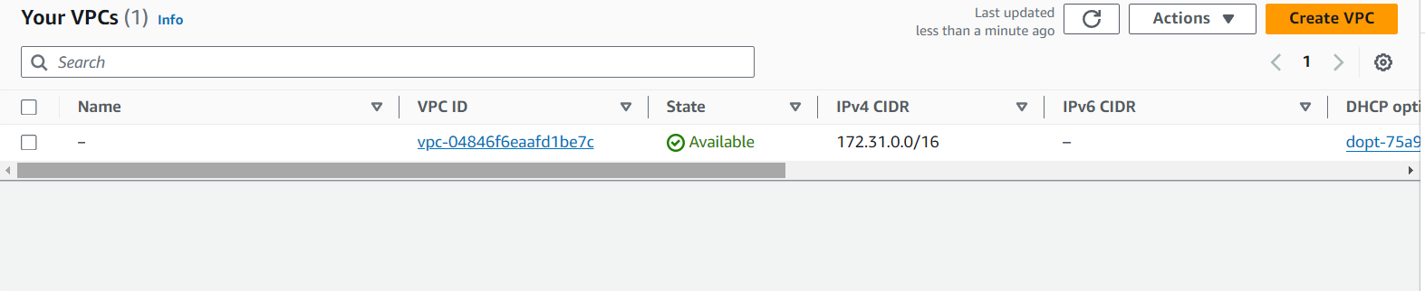

* **Step 3**: Choose **VPC only**.
* **Step 4**: Enter the following details:
  + **Name tag**: (e.g., MyVPC)
  + **IPv4 CIDR block**: 120.0.0.0/16

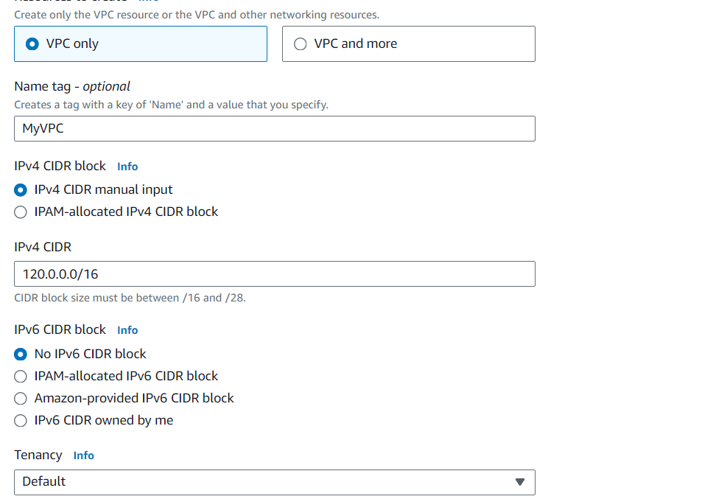

* **Step 5**: Click **Create VPC**.

**Step 2**: Repeat the process to create the second VPC (MYVPC2):

* **Name tag**: MYVPC2
* **IPv4 CIDR block**: Choose a different block (e.g., 120.1.0.0/16)
* Click **Create VPC**.

**2. Create a VPC in the Oregon Region**

* **Step 1**: Switch to the **Oregon (us-west-2)** region in the AWS Management Console.
* **Step 2**: Go to the VPC Dashboard.
* **Step 3**: Click on **Create VPC**.
* **Step 4**: Create the VPC:
  + **Name tag**: VPCOregon1
  + **IPv4 CIDR block**: Choose a suitable block (e.g., 120.2.0.0/16)
  + **Step 5**: Click **Create VPC**.

**2. Create Subnets**

* **Step 1**: In the VPC Dashboard, click on **Subnets** in the left navigation pane, then click **Create Subnet**.
* **Step 2**: Select the VPC you just created.

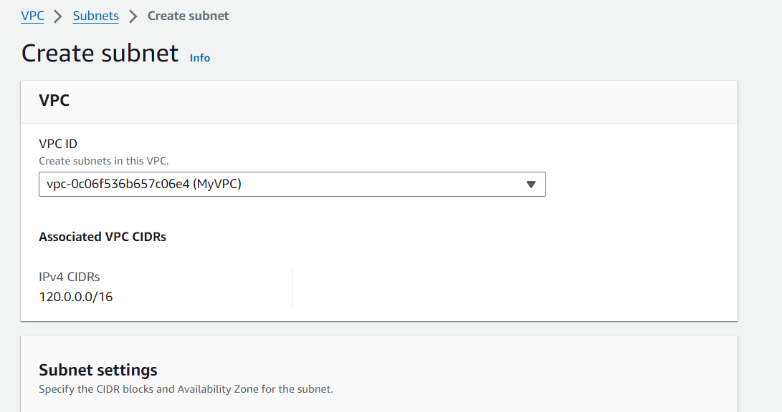

* **Step 3**: Create the public and private subnets:

**Public Subnet**

* + **Name tag**: (e.g., PublicSubnet)
  + **Availability Zone**: Choose one (e.g., us-east-1a).
  + **IPv4 CIDR block**: (e.g., 120.0.1.0/24)
  + **Step 4**: Click **Create Subnet**.

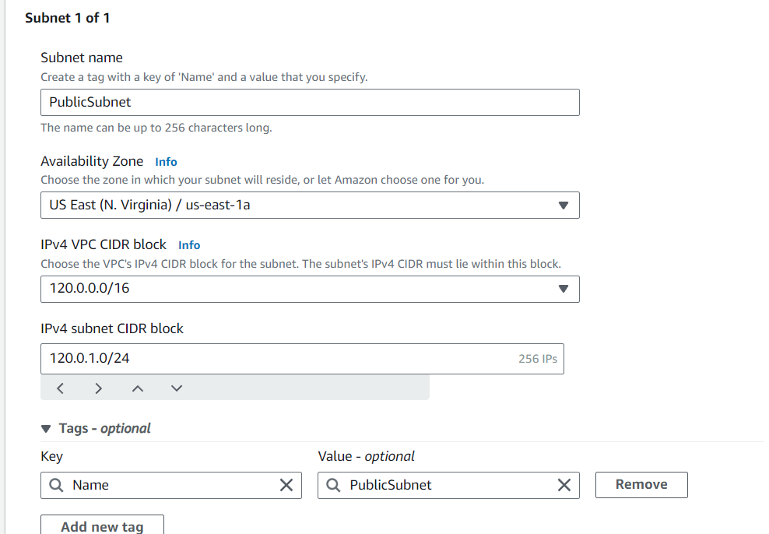

**Private Subnet 1**

* + **Name tag**: (e.g., PrivateSubnet1)
  + **Availability Zone**: Choose another one (e.g., us-east-1b).
  + **IPv4 CIDR block**: (e.g., 120.0.2.0/24)
  + **Step 4**: Click **Create Subnet**.

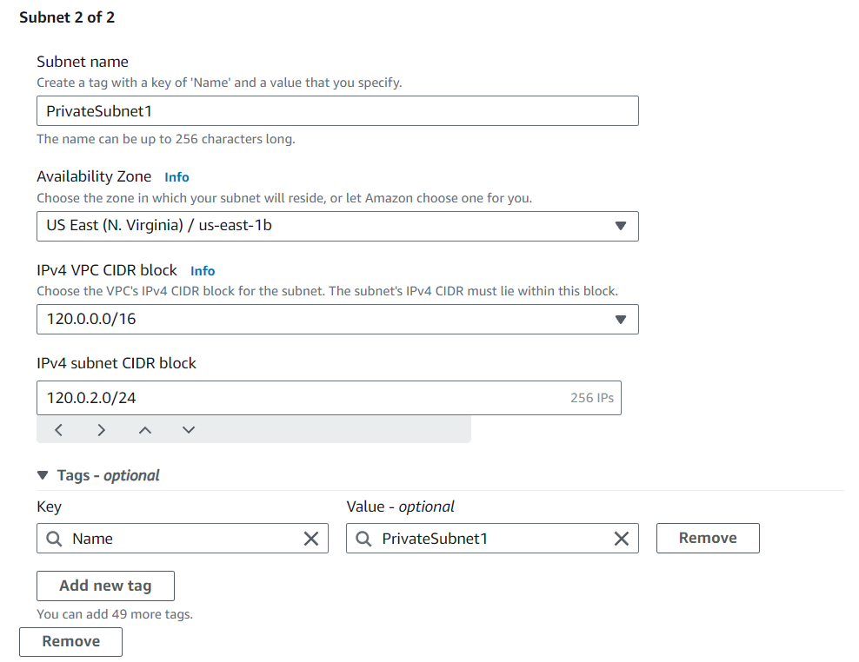

**Private Subnet 2**

* + **Name tag**: (e.g., PrivateSubnet2)
  + **Availability Zone**: Choose the third (e.g., us-east-1c).
  + **IPv4 CIDR block**: (e.g., 120.0.3.0/24)

**3. Create a Peering Connection Between MYVPC1 and MYVPC2**

* **Step 1**: While still in the **North Virginia** region, go to the VPC Dashboard.
* **Step 2**: Click on **Peering Connections** in the left navigation pane.
* **Step 3**: Click **Create Peering Connection**.
* **Step 4**: Enter the following details:
  + **Peering connection name tag**: MYVPC1-MYVPC2-Peering
  + **VPC Requester**: Select MYVPC1
  + **VPC Accepter**: Select MYVPC2
* **Step 5**: Click **Create Peering Connection**.
* **Step 6**: Accept the peering request from **MYVPC2**. Go to the **Peering Connections** page, select the new connection, and click **Actions > Accept Request**.

**4. Create a Peering Connection Between MYVPC2 and VPCOregon1**

* **Step 1**: Switch to the **Oregon** region in the AWS Management Console.
* **Step 2**: Go to the VPC Dashboard.
* **Step 3**: Click on **Peering Connections** in the left navigation pane.
* **Step 4**: Click **Create Peering Connection**.
* **Step 5**: Enter the following details:
  + **Peering connection name tag**: MYVPC2-VPCOregon1-Peering
  + **VPC Requester**: Select MYVPC2 (from North Virginia)
  + **VPC Accepter**: Select VPCOregon1
* **Step 6**: Click **Create Peering Connection**.
* **Step 7**: Accept the peering request from **VPCOregon1**. Go to the **Peering Connections** page, select the new connection, and click **Actions > Accept Request**.

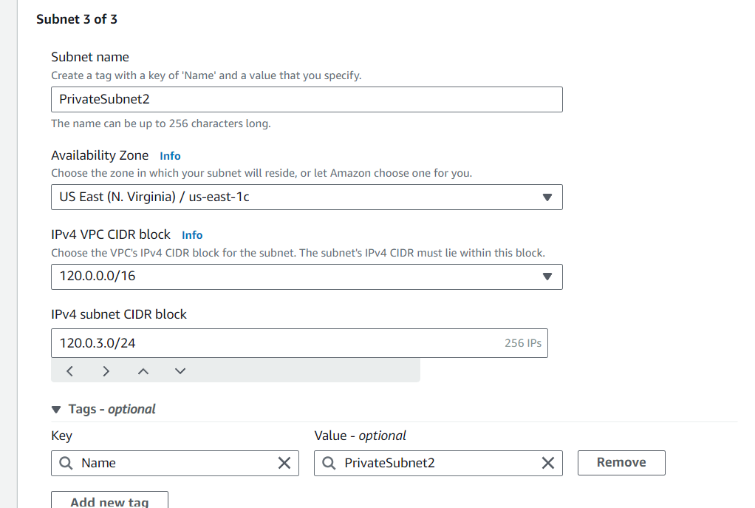

* + **Step 4**: Click **Create Subnet**.

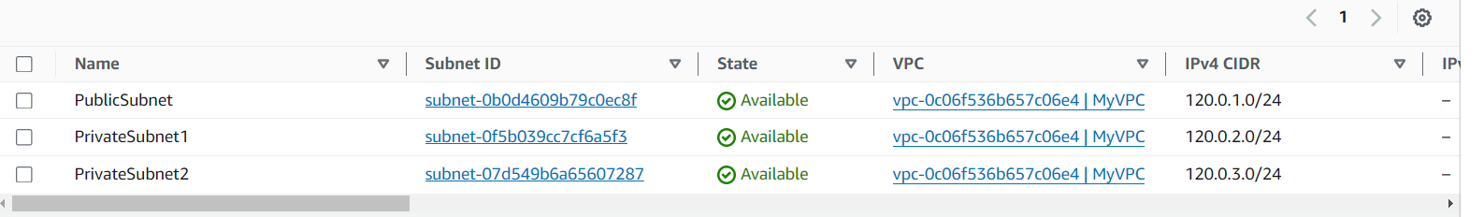

**3. Create an Internet Gateway and Attach it to the VPC**

* **Step 1**: In the VPC Dashboard, click on **Internet Gateways** in the left navigation pane, then click **Create internet gateway**.
* **Step 2**: Enter a name tag (e.g., MyInternetGateway), then click **Create internet gateway**.

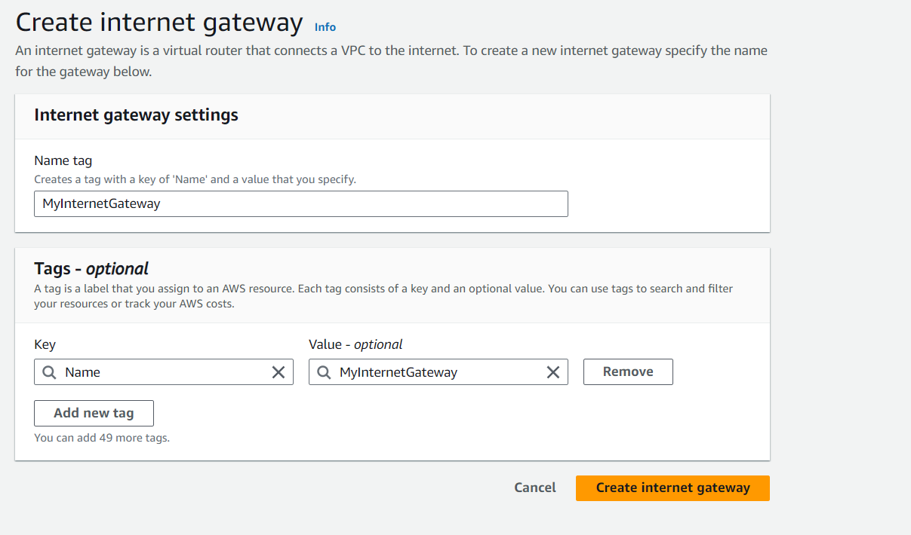

* **Step 3**: Click **Attach to VPC**, select the VPC you created, and click **Attach internet gateway**.

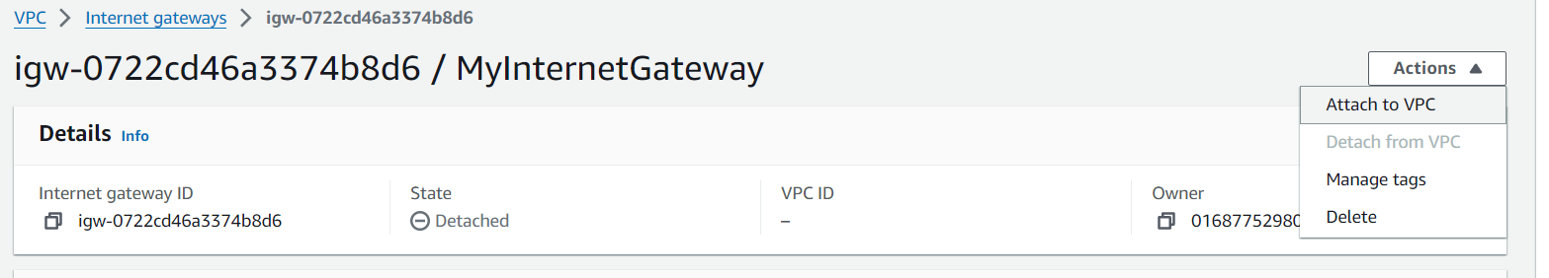

**4. Create a Route Table for the Public Subnet**

* **Step 1**: In the VPC Dashboard, click on **Route Tables** in the left navigation pane, then click **Create route table**.

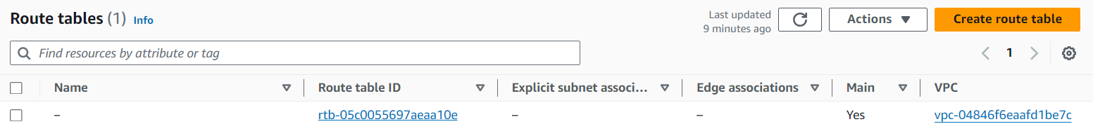

* **Step 2**: Select the VPC you created, and enter a name tag (e.g., PublicRouteTable).

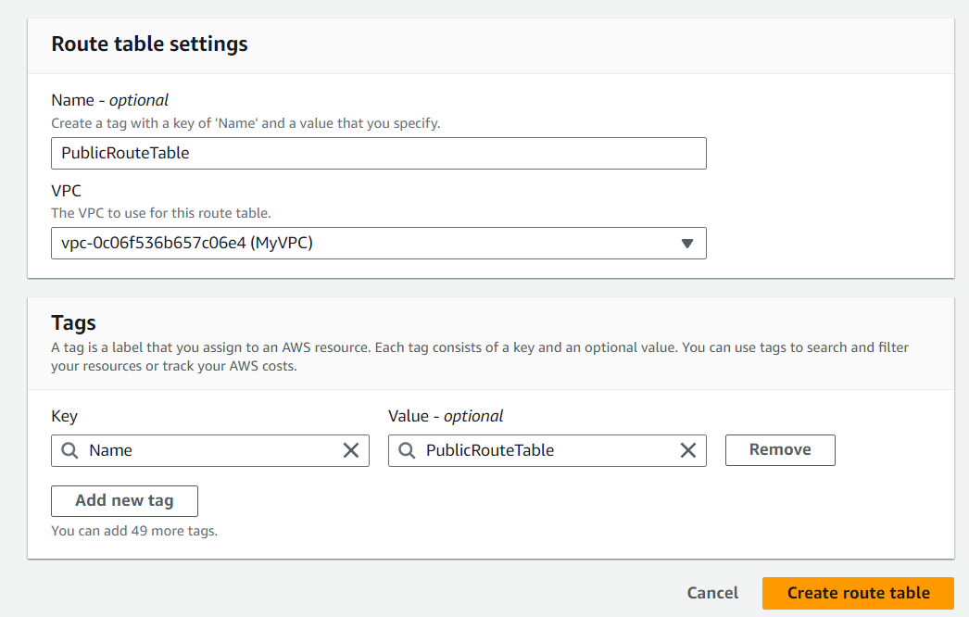

* **Step 3**: Click **Create route table**.
* **Step 4**: Select the newly created route table, and under the **Routes** tab, click **Edit routes**.
* **Step 5**: Click **Add route**:
  + **Destination**: 0.0.0.0/0
  + **Target**: Select your Internet Gateway.
* **Step 6**: Click **Save changes**.

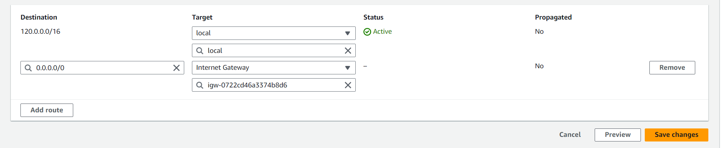

* **Step 7**: Under the **Subnets associations** tab, click **Edit subnet associations** 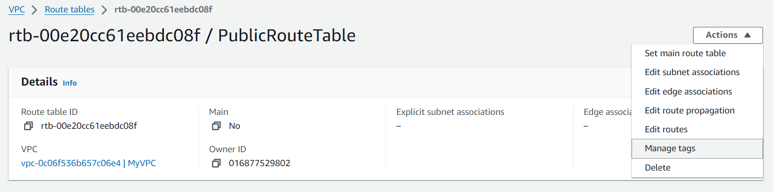
* and select your public subnet.

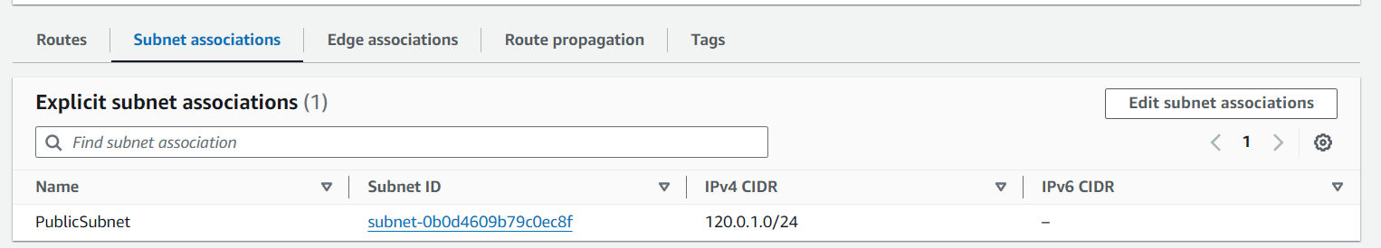

**5. Create a NAT Gateway**

* **Step 1**: In the VPC Dashboard, click on **NAT Gateways** in the left navigation pane, then click **Create NAT gateway**.

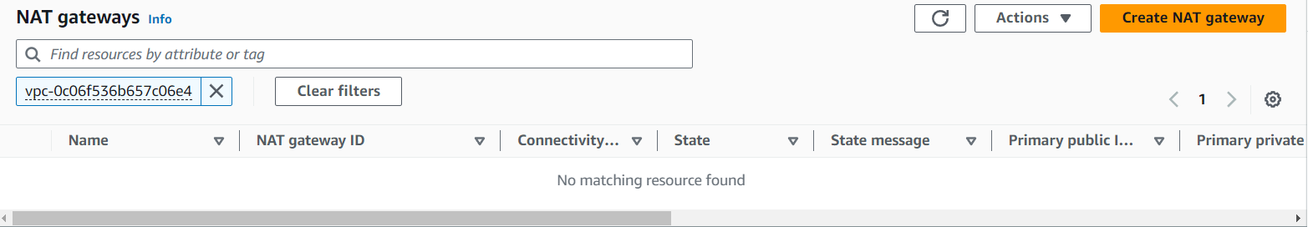

* **Step 2**: Enter the following details:
  + **Name tag**: (e.g., MyNATGateway)
  + **Subnet**: Select your public subnet.
  + **Elastic IP allocation ID**: Allocate a new Elastic IP or select an existing one.
* **Step 3**: Click **Create NAT gateway**.

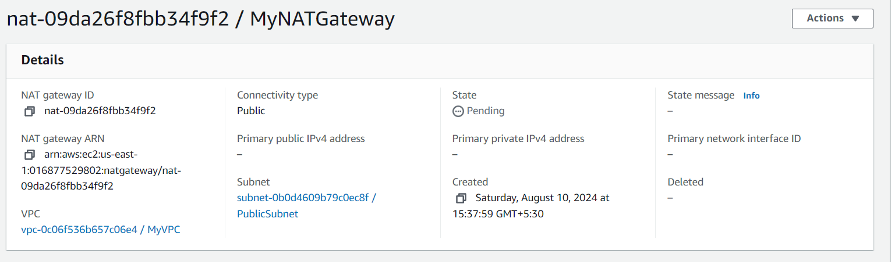

**6. Create a Route Table for the Private Subnets**

* **Step 1**: In the VPC Dashboard, click on **Route Tables** in the left navigation pane, then click **Create route table**.
* **Step 2**: Select the VPC you created, and enter a name tag (e.g., PrivateRouteTable).
* **Step 3**: Click **Create route table**.
* **Step 4**: Select the newly created route table, and under the **Routes** tab, click **Edit routes**.
* **Step 5**: Click **Add route**:
  + **Destination**: 0.0.0.0/0
  + **Target**: Select your NAT Gateway.
* **Step 6**: Click **Save changes**.

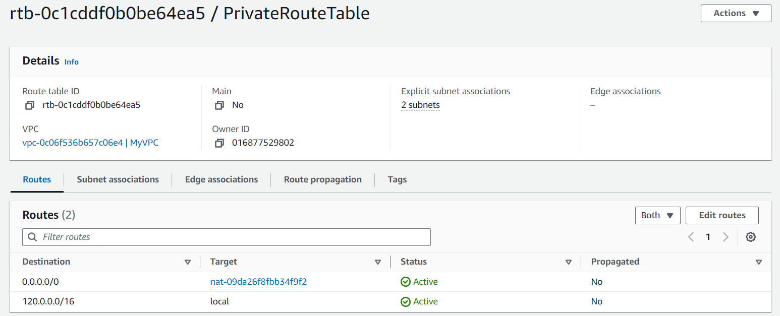

* **Step 7**: Under the **Subnets associations** tab, click **Edit subnet associations** and select your private subnets.

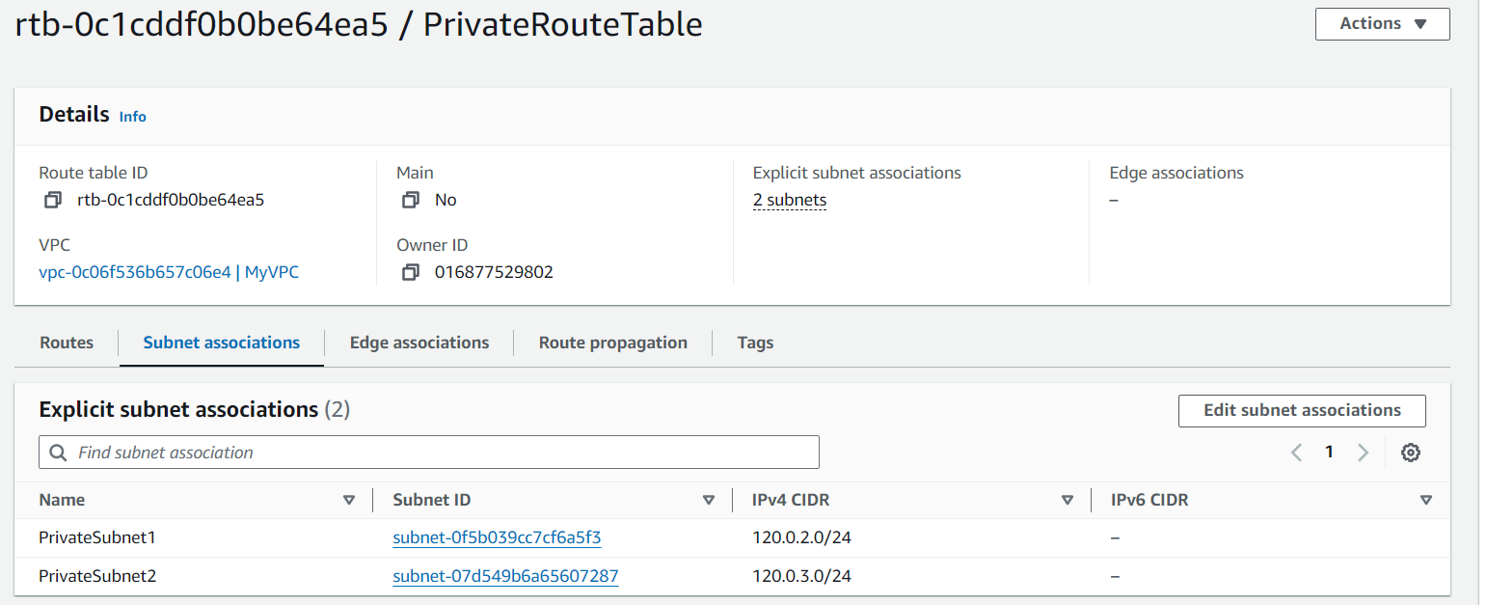

**3. Create a Peering Connection Between MYVPC1 and MYVPC2**

* **Step 1**: While still in the **North Virginia** region, go to the VPC Dashboard.
* **Step 2**: Click on **Peering Connections** in the left navigation pane.

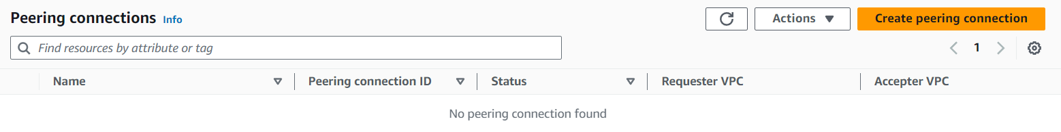

* **Step 3**: Click **Create Peering Connection**.
* **Step 4**: Enter the following details:
  + **Peering connection name tag**: MYVPC1-MYVPC2-Peering
  + **VPC Requester**: Select MYVPC1
  + **VPC Accepter**: Select MYVPC2
* **Step 5**: Click **Create Peering Connection**.

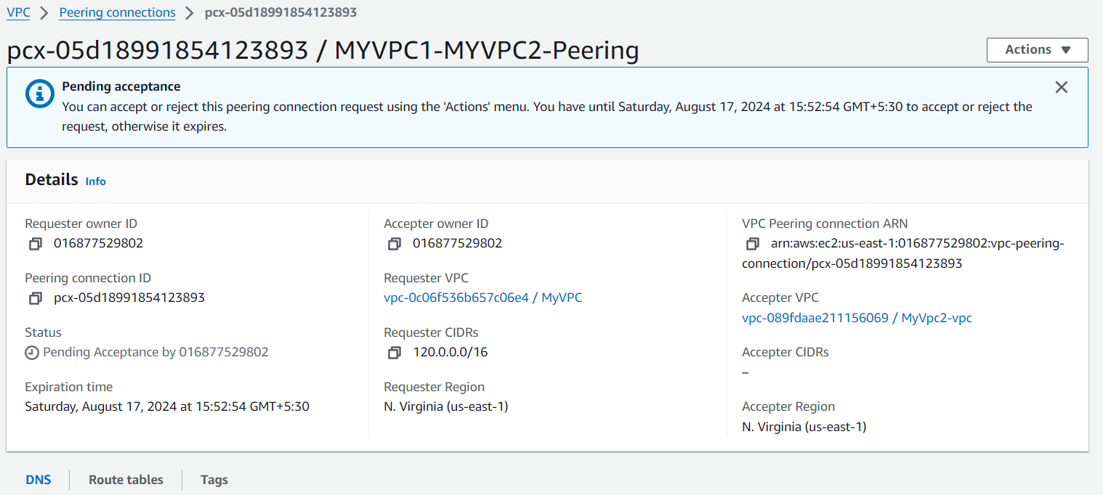

* **Step 6**: Accept the peering request from **MYVPC2**. Go to the **Peering Connections** page, select the new connection, and click **Actions > Accept Request**.

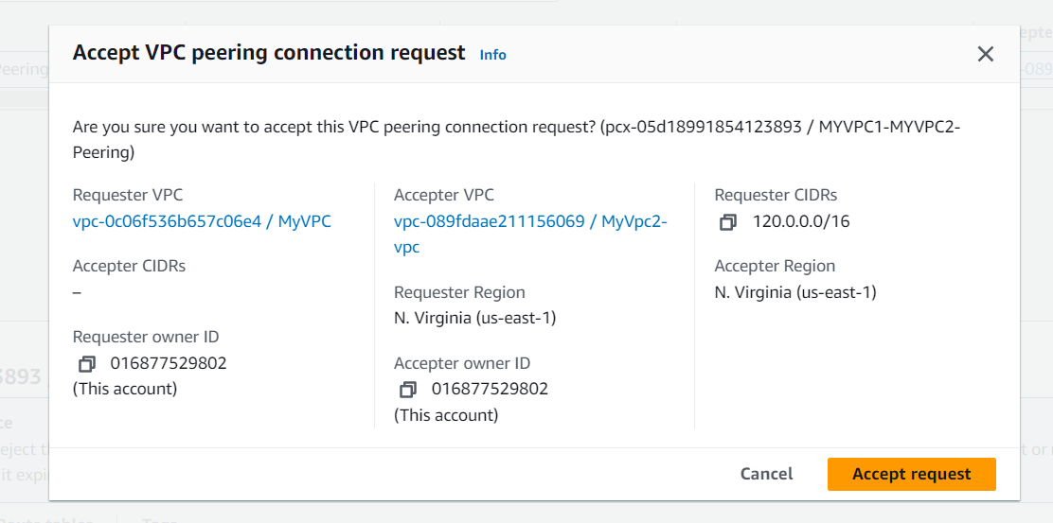

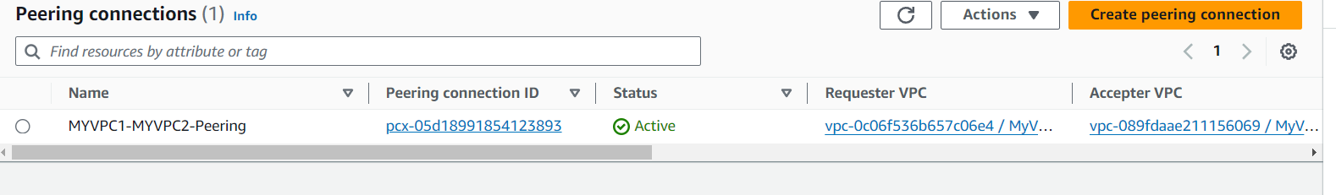

Use same to peer VPC

**4. Create a Peering Connection Between MYVPC2 and VPCOregon1**

* **Step 1**: Switch to the **Oregon** region in the AWS Management Console.
* **Step 2**: Go to the VPC Dashboard.
* **Step 3**: Click on **Peering Connections** in the left navigation pane.
* **Step 4**: Click **Create Peering Connection**.
* **Step 5**: Enter the following details:
  + **Peering connection name tag**: MYVPC2-VPCOregon1-Peering
  + **VPC Requester**: Select MYVPC2 (from North Virginia)
  + **VPC Accepter**: Select VPCOregon1
* **Step 6**: Click **Create Peering Connection**.
* **Step 7**: Accept the peering request from **VPCOregon1**. Go to the **Peering Connections** page, select the new connection, and click **Actions > Accept Request**.